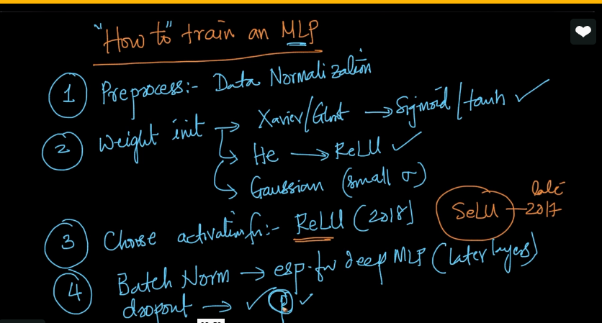
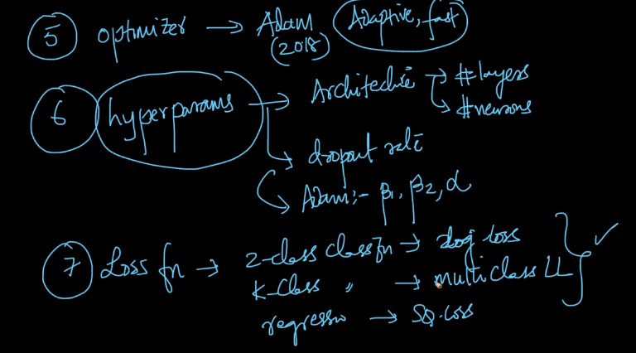
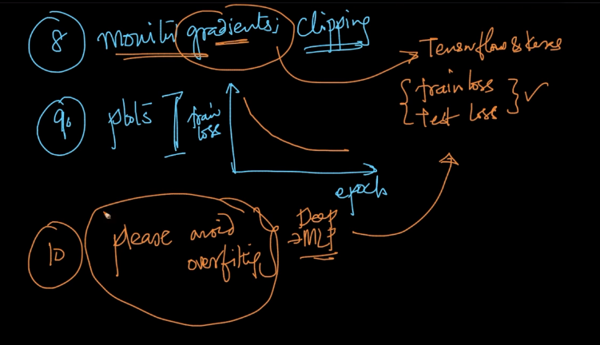

Deep feedforward networks / feedforward neural networks/ Multi layer perceptron/MLP
Target :- the target of MLP is to approximate the target function /classifier .
Y= f*(x) => this function map the input x with output y , the feedword network define the mapping Y= f*(x,thita) and learn the value of perameter thitha , that result in best function approximation.
Why it is feedforward:- In feedforward neural network the information flow through the function being evaluated from x through some intermediate layer than output being computed . the connect is always feedforward between layers and activation function. There is not feedback connect
In Recurrent nueral network the connection is feedback.

Why we multiply input with weight in nueral network
Why we apply activation function?
Ans . to introduce non linearity ( Need to learn non linear function)

Activation function should be :
- Non linear
- It should be differentiable
Why differentiability is important?

Why non linearity is important in learning?
ANs.
Nueral function are universal function approximator.

Polynomial function :
Line/hyperplan are the polynomial of one degree . no curve
Linear functions are Limited in complexity
Non linear function are Polynomial of higher degree
Like , hiperbola ,sphere , trade function.
Non linearity makes it easy for the model to generalize or adapt with variety of data and to differentiate between the output.

Tenser flow
https://www.tensorflow.org/get_started/
https://learningtensorflow.com/
https://cloud.google.com/blog/big-data/2017/01/learn-tensorflow-and-deep-learning-without-a-phd
playground.tensorflow.org

Identity function vs activation function?

Decision

Problems with deep nueral network?
Problem in training of deep feedforward nueral network?
http://proceedings.mlr.press/v9/glorot10a/glorot10a.pdf
https://towardsdatascience.com/how-do-we-train-neural-networks-edd985562b73

Builind NL from scratch without anyframwork
http://neuralnetworksanddeeplearning.com/chap1.html
vuild NL from scratch for coder DL framwork
https://www.fast.ai/

http://cs231n.stanford.edu/syllabus.html
ravines

Question
- Problems with Random Weight initialization with normal distribution mean 0 and standard deviation 1?
- Problems with Weight initialization 0?
- Problems with weight initialization with 1?
- Right strategies to initialize weight?

Sigmoid /logistic activation
- What is disadvantage of Sigmoid function?
- What is the mean of logistic function ? (0.5) <- which could be consider as disadvantage

Tanh function
- Tanh function has mean – 0 <-
- How mean value can significantly impact the network performance?

- Internal Covariate Shift problem?

Points
- Variance of output of layer vs Variance of input into layer
- The Variance of output should be equals to variance of input into layer. Make sure it should not be large that cause problems in network such as vanishing gradient.
- The variance of gradients should be equals before and after flowing from network in reverse direction .
- The above points only can be guaranteed if layer having the same number of inputs and outputs connections .
- So solution to achive this is proper random weight initialization as
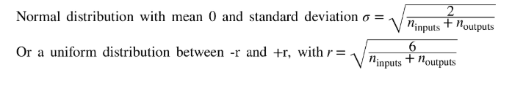
Above is Glorot/Xavier weight initialization.

Sigmoid :-
1. As the input(X) value grow bigger and bigger in negative or positive direction the sigmoid fuction output start saturating at the 0 and1 .
2. Problem in vanishing gradient :- The gradient of sigmoid function with respect to input is between
0 and 0.25 , as input start growing the gradient start tending towards 0 . when backpropagation kick in there will be no gradient to backpropogate . or it is two small (because of multiplicative factor of gradient become small) which lead to weight virtually unchanged . what if little gradient exist it keep diluted as backpropagation progress towards top layer from bottom.
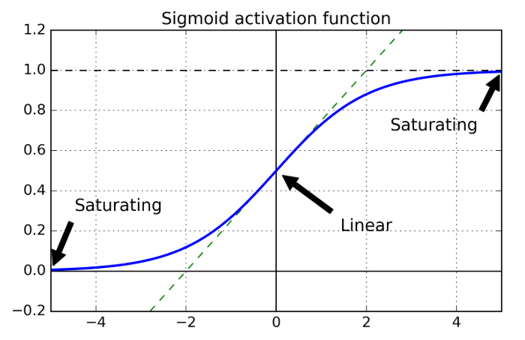
Relu :- 1. It is non saturated Activation function. It is not saturated for the positive values
- It is fast in convergence/compute .
- Problems with Relu :- Dying relus ->
- Gradient :- Gradient of Relu lie between [0,1] 0 when input is negative. And 1 for positive value
- Leaky relu :-- Aplha is hyper perameter. The alpha tell how much function can leak when Z<0 . by default the alpha is set to 0.01(small leak)
- This was reported to strongly outperform ReLU on large image datasets, but on smaller datasets it runs the risk of overfitting the training set

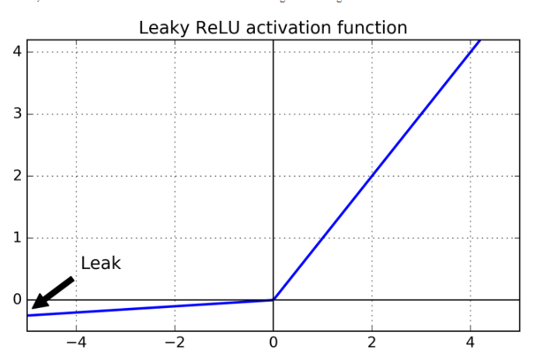
Question :-
- So which activation function should you use for the hidden layers of your deep neural networks?
Ans :- Although your mileage will vary, in general ELU > leaky ReLU (and its variants) > ReLU > tanh > logistic. If you care a lot about runtime performance, then you may prefer leaky ReLUs over ELUs. If you don’t want to tweak yet another hyperparameter, you may just use the default α values suggested earlier (0.01 for the leaky ReLU, and 1 for ELU). If you have spare time and computing power, you can use cross-validation to evaluate other activation functions, in particular RReLU if your network is overfitting, or PReLU if you have a huge training set.

Batch Normalization :- This is another solution for vanishing and exploding gradient .
Paper :- https://arxiv.org/pdf/1502.03167v3.pdf
It having calculation of calculating the mean and standard deviation . It does so evalutiing of mean and standard deviation of input over the batch. That’s why it is refered as Batch normalization.
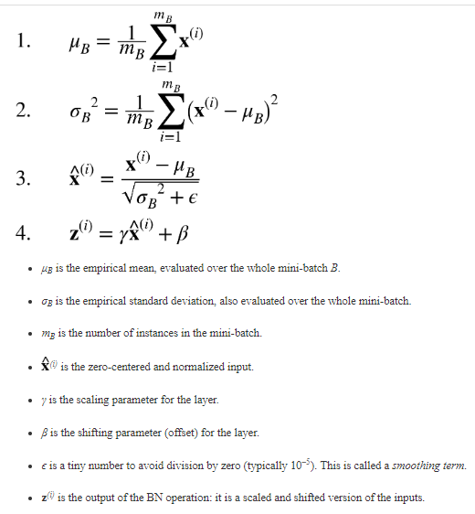

Importatnt read
https://www.researchgate.net/publication/243648538_Some_methods_of_speeding_up_the_convergence_of_iteration_methods

SGD
http://ruder.io/optimizing-gradient-descent/

SGD Momemntum

Why momentum work :- https://distill.pub/2017/momentum/

